# XAMPP & phpMyAdmin

For the remainder of the course you will need to have a local database installed. This will allow you to complete Labs that require creating SQL scripts. I have linked youtube videos below, depending on your system.

Windows:<https://www.youtube.com/watch?v=dnBa2pTKYY0>

Mac:<https://www.youtube.com/watch?v=EuIl_Crv8vg>

If you are on Linux the process is similar to the above videos. Let me know if there are any issues and we can work through them in class.

# Adminer

Adminer is an alternate way to access our Database Management System (DBMS) phpMyAdmin. I suggest installing this after following the above instructions. Adminer has a much simpler interface to write and view the results of queries.

*Following setup is only tested on Windows. If on Mac or Linux, please try the steps below and let me know if there are any issues and we can work through them in class.

## Download/Install

1. First download **Adminer 4.8.1 for MySQL** from<https://www.adminer.org/#download>
2. Once downloaded rename the downloaded file to **adminer**
3. Open a new finder window. Navigate to
   1. Windows: **C:\xampp\htdocs**
   2. Mac: **/Applications/XAMPP/xamppfiles/etc/httpd**
4. Move the downloaded file, now named **adminer**, to this directory
5. Launch your Apache server and MySQL server. Navigate to [localhost/adminer.php](http://localhost/adminer.php). You should see something like this

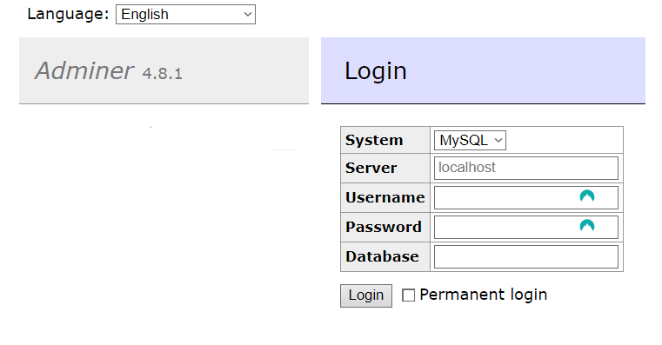

## Account Setup

Before you can login you need to set up an account.

1. Navigate to<http://localhost/phpmyadmin/>
2. Select the **User accounts** tab
3. Find **New,** select **Add user account**
4. Set new account
   1. **Username** and **Password** should be set to whatever you prefer.
   2. All other settings should match the picture below
   3. Click **Go**

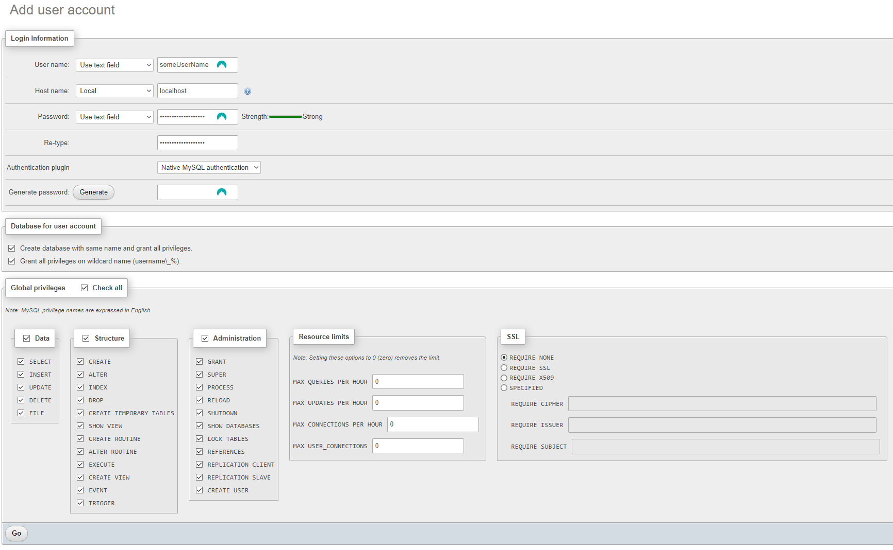

## Login to Adminer

* Navigate to<http://localhost/adminer.php>
* Login using credentials you set above
* System: **MySQL**
* Server: **localhost**
* Database: <blank>

